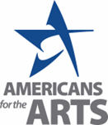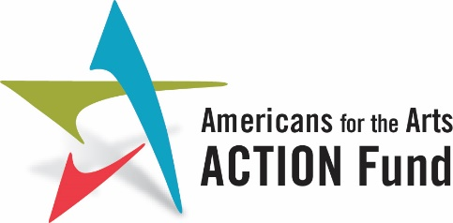
Support Arts Education in ESSA and ESRA
In December 2015, Congress passed bipartisan legislation to reauthorize the Elementary and Secondary Education Act (ESSA) in landslide votes. ESSA, the current iteration of the Elementary and Secondary Education Act of 1965 (ESEA) includes art and music in the definition of a "well-rounded education." Within ESSA, there are several opportunities for the federal government to fund and support equitable access to arts education for K-12 students around the country.

Eligibility under Titles I, II, and IV of ESSA
Along with the specified arts education funding under AAE, there are several other avenues for the arts to receive funding within ESSA. Title I, which focuses on providing personnel, instruction, and interventions to help close achievement gaps, can be used to address the huge, persistent disparities in access to arts education in public schools. Title II, which focuses on preparing, training, and recruiting high-quality teachers, principals, and other school educators, can be utilized to obtain professional development funding for arts educators. Finally, Title IV, Part A, which contains the Student Support and Academic Enrichment Grants, may be used to support the arts as part of a well-rounded education.

Assistance to Arts Education Program
The Assistance for Arts Education program within ESSA has received consistent bipartisan support from Congress year after year, with the programming receiving a $500,000 increase to be funded at a level of $36 million in FY 2023. The Assistance for Arts Education (AAE) program, authorized under Title IV of ESSA, has directed arts education grants to more than 230 congressional districts in 33 states. These grants can be used to support standards-based arts education, integration of arts instruction into other subject areas, arts education projects targeted for low-income families and students with disabilities, and professional development for arts educators.

National Arts Education Data Collection
The Education Sciences Reform Act must be reauthorized to successfully provide, evaluate, and advocate for equitable arts education programs on a national scale with the existence of accurate and up-to-date data. Particularly important are the Fast Response Survey System in Arts Education study, which measures arts education access in various communities around the country, and the National Assessment of Educational Progress (NAEP), which measures student proficiency in dance, theater, music, and visual arts. The most recent FRSS study in Arts Education was released in 2012, meaning that much of the data may no longer be applicable. While the newest NAEP data for the arts is more recent (published in 2016), the arts were recently removed from the 10-year calendar of assessments by the National Assessment Governing Board. The continuation of the FRSS and NAEP serve as invaluable sources of data in understanding the state of arts on a national scale.
We urge Congress to:

- Strengthen equitable access to arts education through the Well-Rounded Education provisions of the Every Student Succeeds Act (ESSA).
- Fund the U.S. Department of Education’s Assistance to Arts Education program at $40 million.
- Appropriate the President’s request of $20.5 billion for Title I, Part A to help disadvantaged children achieve proficiency in arts education and improve arts education programs in low-achieving schools.
- Support professional development for arts educators and increase the number of high-quality teachers by appropriating $2.4 billion for Title II, Part A.
- Provide $1.65 billion in support for the Student Support & Academic Enrichment Grants under Title IV, Part A, to support Well-Rounded Education.
- Provide $1.8 billion in support for the Nita Lowey 21st Century Community Learning Centers (21stCCLC) after-school program.
- Require the U.S. Department of Education to issue annual policy memoranda promoting the eligibility under current law for the arts to be supported through Title I funds and through professional development opportunities for arts educators under Title II.
- Provide at least $4 million for the Institute of Education Science to implement a Fast Response Survey System (FRSS) study in the arts; include pre-K–12 arts education in the annual School and Staffing Survey and other data instruments; and, restore and appropriately fund the arts in the National Assessment of Educational Progress (NAEP), including full and robust assessments in dance, theater, media arts, music, and visual art.

Source: Content assembled by the Cultural Advocacy Group, a collaboration of arts and culture stakeholders working collectively to advance federal policy, and by Americans for the Arts.

