**National Endowment for the Arts: Promoting Creativity and Public Access to the Arts**

We urge Congress to:

* Continue bipartisan support and robust funding for the National Endowment for the Arts (NEA) in the FY 2024 Interior Appropriations bill at no less than $211 million to broaden access to the cultural, educational, and economic benefits of the arts and to advance creativity and innovation in communities across the United States.
* We encourage the Subcommittee to build a specific path to index funding for the National Endowment for the Arts and National Endowment for the Humanities (NEH) at $1 per capita. Each agency is currently funded at about 62 cents per capita. We also encourage continued parity between NEA and NEH funding.

**BACKGROUND**

The NEA’s FY 2023 budget is $207 million, just 0.004% of the federal budget and 62 cents per capita. The Administration’s FY 2024 budget request for the NEA is $211 million.

* The National Endowment for the Arts (NEA) plays a unique role in broadening access to and participation in the arts in every congressional district and should be more fully supported to expand and deepen its impact on our communities and our democracy. The arts sector is an economic engine that brings people together. As the nation continues to emerge from the COVID-19 pandemic, the arts and culture sector is uniquely able to deliver on its mission to uplift, engage, educate, and innovate. The NEA can help leverage the arts sector to play a key role in the work to imagine and build a new American economy. The Arts Endowment’s goals are fulfilled by awarding 60% of its grantmaking budget in direct grants—reviewed and recommended by panels of experts—to arts organizations across the country, and which signal artistic achievement and recognition.  It awards the remaining 40% of its grantmaking budget directly to the states through state and regional arts agencies, an extraordinary example of federal/state partnership, extending the NEA’s reach further to millions of people in thousands of communities.

**Key facts about the NEA:**

* NEA annually recommends, on average, 2,300 grants across every Congressional District in the country. Most grants go to small- and medium-sized organizations (budgets less than $2 million), and support projects that increase audience access to arts programming.
* 35% of Arts Endowment grants take place in high-poverty neighborhoods.
* 35% of grants reach low-income audiences of under-resourced populations such as people with disabilities, people in institutions, and Veterans.
* Federal agencies and nonprofit organizations partner with the Arts Endowment on national initiatives, using the arts as a platform for enhancing the quality of life for all. Such partnership examples include Creative Forces, Poetry Out Loud, Musical Theater Songwriting Challenge, NEA Big Read, Blue Star Museums, and the Citizens’ Institute on Rural Design.
* Approximately 4,000 communities are served each year through NEA grants. Around 41 million Americans annually attend a live arts event supported by the NEA, including approximately 36,000 concerts, readings, and performances, and 6,000 exhibitions.

**The NEA Provides a High Return on Investment:**

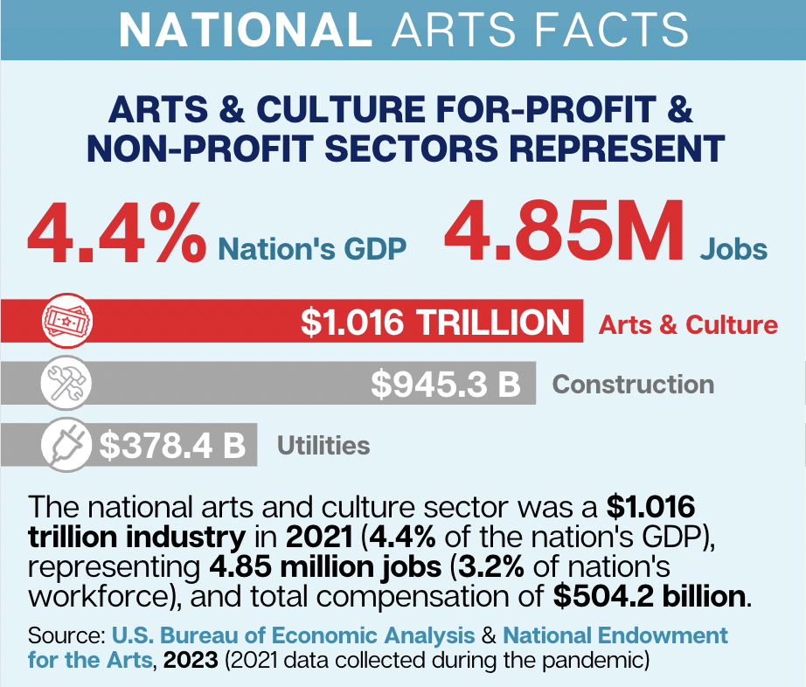

* The ratio of private and other non-federal government funds matching every NEA grant dollar is 9:1, far surpassing the required non-federal match of at least 1:1. This generated more than $500 million in matching support and illustrates why federal support for the arts is uniquely valuable.
* Data released by the [U.S. Bureau of Economic Analysis](https://www.bea.gov/news/2023/arts-and-cultural-production-satellite-account-us-and-states-2021) last month showed that arts and cultural economic activity accounted for 4.4% of gross domestic product (GDP), or $1.02 trillion, in 2021. This new high-water mark represents a larger percentage of GDP than powerhouse sectors like transportation, construction, and agriculture.

**Source:** Content for this issue brief was assembled by the Cultural Advocacy Group, a collaboration of arts and culture stakeholders working collectively to advance federal policy, and by Americans for the Arts.