2023 May Fly-In
Congressional Member Social Media Handles

Alabama
- Senator Katie Britt (R-AL)
Instagram Handle – @katieboydbritt
Twitter Handle – @senkatiebritt

- Congressman Robert Aderholt (R-AL-04)
Instagram Handle – None
Twitter Handle – @robert_aderholt

California

- Senator Feinstein (D-CA)
Instagram Handle – None
Twitter Handle – @SenFeinstein

- Senator Padilla (D-CA)
Instagram Handle – @senalexdpadilla
Twitter Handle – @SenAlexPadilla

- Congressman Ken Calvert (R-CA-41)
Instagram Handle – @repkencalvert
Twitter Handle – @TeamCalvert

- Congressman Pete Aguilar (D-CA-33)
Instagram Handle – @rep.peteaguilar
Twitter Handle – @aguilarpete

- Congressman Josh Harder (D-CA-09)
Instagram Handle – @repjoshharder
Twitter Handle – @JoshHarder

- Congressman Raul Ruiz (D-CA-25)
Instagram Handle – @repraulruizmd
Twitter Handle – @repraulruizmd

- Congressman Mark Takano (D-CA-39)
Instagram Handle – @repmarktakano
Twitter Handle – @RepMarkTakano

Florida

- Senator Rick Scott (R-FL)
Instagram Handle – None
Twitter Handle – @senrickscott

- Senator Marco Rubio (R-FL)
Instagram Handle – @senatormarcorubio
Twitter Handle – @marcorubio

- Congresswoman Sheila Cherfilus-McCormick
Instagram Handle – @sheilacherfilusmccormick
Twitter Handle - @congresswomansc

- Congresswoman Debbie Wasserman Schultz (D-FL-25)
Instagram Handle – @repdws
Twitter Handle - @repDWStweets

Idaho

- Senator Crapo (R-ID)
Instagram Handle – @mikecrapo
Twitter Handle - @MikeCrapo
- Senator Risch (R-ID)
Instagram Handle – None
Twitter Handle – @SenatorRisch

- Congressman Mike Simpson (R-ID-02)
Instagram Handle – None
Twitter Handle – @CongMikeSimpson

Oregon
- Senator Wyden (D-OR)
Instagram Handle – None
Twitter Handle – @ronwyden

- Senator Jeff Merkley (D-OR)
Instagram Handle - @senjeffmerkley
Twitter Handle – @SenJeffMerkley

- Congresswoman Suzanne Bonamici (D-OR-01)
Instagram Handle - @repbonamici
Twitter Handle – @RepBonamici

- Congressman Earl Blumenauer (D-OR-03)
Instagram Handle – None
Twitter Handle – @repblumenauer

Pennsylvania

- Senator Bob Casey (D-PA)
Instagram Handle – None
Twitter Handle – @senbobcasey

- Senator John Fetterman (D-PA)
Instagram Handle – None
Twitter Handle – @senfettermanpa

- Congressman Guy Reschenthaler (R-PA-14)
Instagram Handle - @greschenthaler
Twitter Handle – @greschenthaler

Texas

- Senator Cruz (R-TX)
Instagram Handle - @sentedcruz
Twitter Handle - @SenTedCruz

- Senator Cornyn (R-TX)
Instagram Handle - @johncornyn
Twitter Handle - @JohnCornyn

- Congressman Henry Cuellar (D-TX-28)
Instagram Handle – None
Twitter Handle - @repcuellar

- Congressman John Carter (D-TX-31)
Instagram Handle – None
Twitter Handle - @judgecarter

Virginia
- Senator Warner (R-TX)
Instagram Handle - @johncornyn
Twitter Handle - @JohnCornyn

- Senator Tim Kaine (D-VA)
Instagram Handle – None
Twitter Handle - @timkaine

Washington

- Congressman Derek Kilmer (D-WA-06)
Instagram Handle – None
Twitter Handle - @repderekkilmer

Social Media Sample Tweets for
Instagram, Facebook, and Twitter

Tuesday, May 16, 2023
Training Day Post
Please note Morgan will send each fly-in advocate their customized message and graphic via text to copy and paste to their social media platforms.
Language:
Will meet [Congressperson @username] & staff tomorrow on Capitol Hill to discuss economic power of the arts & community arts engagement at V.A. & DoD. #ArtsAdvocacy @Americans4Arts @ArtsActionFund
Image Example:
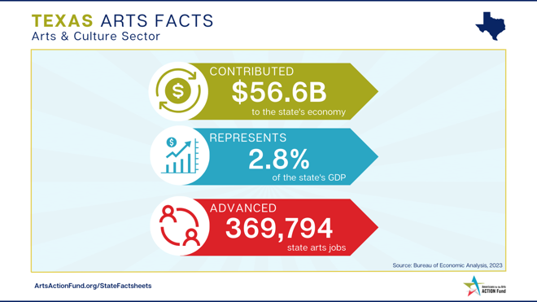

Wednesday, May 17, 2023
Meeting Day Post
Language:
Thank you [Congressperson’s @username] office for the opportunity to discuss arts policy and funding issues @NEAarts, tax policy, arts education, and community arts engagement opportunities at DoD & V.A. #ArtsAdvocacy @Americans4Arts @ArtsActionFund

Image:
Picture of you with member of Congress and/or staff.

