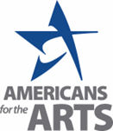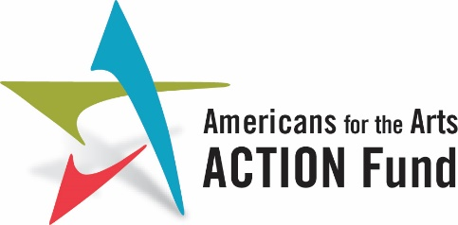

Community Arts Engagement for the Health and Well-Being of Our Veterans

We urge Congress to:

Fund $10 million in the FY24 Military Construction, Veterans Affairs and Related Agencies Appropriations Bill to a coordinate public-private sector collaborative efforts that support stronger clinic to community collaborations and advances grassroots and innovative solutions, practices and knowledge in the arts and humanities across VA entities.

BACKGROUND
More than 400,000 men and women of our armed services have been diagnosed with traumatic brain injuries (TBI) since 2000 and 11-20 percent of all veterans who served in Iraq and Afghanistan have post-traumatic stress disorder (PTSD) each year. Participation in creative community arts programs can help individuals process the “invisible wounds” of war and help them heal.
Community programs focus on creative expression, particularly in ways that enhance a participant’s understanding of themselves and others. They help identify social connectedness, and the ability to establish supportive relationships that help develop a sense of belonging in a place or a community. They can help develop resilience, rebounding from stress or unexpected events or challenges. This supports independence and successful adaptation to civilian life. Building a connection to community and sense of belonging for veterans will achieve contribute to achieving healthy outcomes.
In FY2020, Congress included language in the MilConVA Appropriations bill (page 52) supportive of increasing creative arts therapies and arts partnerships through the VA. Specifically, the language states, “Creative Arts Therapies.—The Committee acknowledges the effective use of creative arts therapies in treating Veterans with traumatic brain injuries and psychological health conditions. The Committee supports the integration of the arts and creative arts therapies provided by VA’s Office of Patient Care and Cultural Transformation through the Whole Health initiative and encourages VA’s continued partnerships with healing arts providers.”

Outside of internal VA structures, community arts partners need support in understanding the needs of Veterans and their families, in making connections with VA Medical Centers, and assistance in developing the appropriate tools and methods to evaluate their program’s effectiveness. The VA’s Whole Health assessments have found that among the successful strategies that can be employed to help Veterans achieve their specific Whole Health goals, long-term community partnerships are often the most difficult to initiate, implement and sustain. As such, finding an innovative solution must include addressing the systemic needs both within the VA’s infrastructure and throughout the national-state-local arts networks and ecosystems.

These funds may be used for:

- Continuing the successful effort to expand creative arts therapist positions, especially in rural and underserved regions.

- Phasing in local community arts direct support for therapeutic arts activities that support Veteran health and well-being and Veterans Health Administration (VHA) priorities, including mental health and suicide prevention.

- Supporting staff or FTE contracted positions as needed to support the innovation solution development, program coordination and oversight, including support for VA research and evaluation staff in the design and implementation of programs.
- Developing and publishing educational and multimedia training materials for how VAs can partner with community arts organizations, evaluation methods, and synthesizes report on the national program evaluation findings.
- Developing training and online curriculum materials to increase local arts agencies and local arts providers knowledge and competency about how to partner productively with local VHA facilities, including knowledge-building in Whole Health methods and processes, Veteran cultural competency, and understanding how to contribute to VHA local initiatives underway including participating in Veteran Community Partnerships initiatives.
- Collaborating with VHA to design a pilot evaluation program for local arts agencies and community arts providers working with VA Arts and Humanities in Whole Health or engaging in local Veteran Community Partnerships.
- Supporting a dedicated Veteran community arts engagement specialist staff position(s) or contracted position(s) and subject matter experts in community arts engagement metrics and evaluation to support community arts partnership infrastructure development and evaluation activities.
- Supporting arts and culture asset mapping and the development local arts and culture resource directories for use by VA sites.

