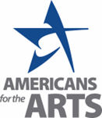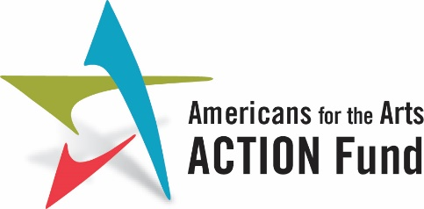

Community Arts Engagement for the Health and Well-Being of Our Military

We urge Congress to:

Fund $22 million in the FY24 Defense Appropriations bill to the Department of Defense’s (DoD) Morale, Welfare and Recreation (MWR) for the support and expansion of community arts programs and partnerships in all military services. The funding is designed to pilot a coordinated local public-private sector strategy for building a partnership between military bases in the United States and the local and regional arts agencies to expand opportunities for service members and their families to participate in the arts for their health and well-being.
Background
More than 400,000 men and women of our armed services have been diagnosed with traumatic brain injuries (TBI) since 2000 and 11-20 percent of all veterans who served in Iraq and Afghanistan have post-traumatic stress disorder (PTSD) each year. Participation in creative in community arts programs can help individuals process the “invisible wounds” of war and help them heal.
Community programs focus on creative expression, particularly in ways that enhance a participant’s understanding of themselves and others. They help identify social connectedness, and the ability to establish supportive relationships that help develop a sense of belonging in a place or a community. They can help develop resilience, rebounding from stress or unexpected events or challenges. This supports independence and successful adaptation to civilian life. Building a connection to community and sense of belonging for veterans will achieve contribute to achieving healthy outcomes.
Support and expansion of community arts programs and partnerships in all military services for the physical and mental health and well-being of service members and their families are vital. The requested funding to the DoD’s MWR will support opportunities to promote military readiness, recruitment, retention, and resilience through the arts, by coordinating and expanding partnerships with local arts agencies and community arts organizations.

By partnering with local and/or regional arts agencies or groups providing arts services, military personnel, and their families, benefit from being connected to work with a diversity of local arts partners. Funding to MWR will allow arts partners to design programs and provide multiple options that meet the specific needs of service members and their families.

Participation in the arts helps foster resilience, reduces the impact of trauma, builds social connectedness, as well as strengthens coping skills for military members and their families. Community arts programs and partnerships play a valuable role in extending the opportunity for continued recovery and growth that may have begun as part of a clinical treatment program, as well as offer options for service members and their families to improve their health and well-being outside of a clinical setting or in the context of formal treatment.
Funds may be used for:

- Supporting a community arts coordinator staff or contracted position(s) to interface with national and local partners and to conduct outreach, communication, program design, and partnership development.
- Designing and implementing a program evaluation to understand the benefits of service members and family engagement in the programs. Funding for local MWR programs to contract with artists and arts groups to provide services.
- Funding to engage with a community partner to provide additional operational, program and evaluation support to support local MWR and community arts partnership development.
- Training programs for local arts agencies and providers to improve programming services.
- Providing training programs for local arts agencies and local arts providers in military cultural competency to improve arts programming for service members.
- Conducting arts and culture asset mapping activities around each of the DoD sites participating in the MWR community arts engagement programs provide localized data to MWR local offices.
- Supporting digital upgrades to connect military populations to arts and cultural organizations.
- Technical assistance to local arts agencies and community arts providers working with DoD MWR programs.
- Providing a report of findings from local evaluations to gather lessons learned, and report findings to DoD partners for continuous improvement of programs and support structures.

