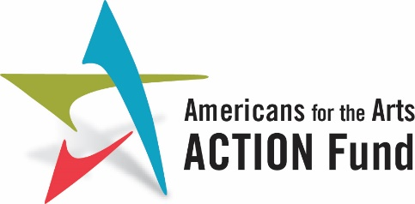
Advancing Equity in the Arts and Humanities Act of 2023
H.R. 3239
We urge Members of Congress to:
Co-Sponsor H.R. 3239, the Advancing Equity in the Arts and Humanities Act of 2023.
The Advancing Equity in the Arts and Humanities Act would create a grant program through the National Endowment for the Arts (NEA) and the National Endowment for the Humanities (NEH) for nonprofit and public entities, including faith-based and community organizations, that serve and are led by people of color. The program aims to support arts and humanities projects that work to dismantle systemic racism through the arts and humanities.
Background:
Everyone should have access to the arts. The truth is, however, that many traditionally underserved populations have inequitable access to the arts in their communities. These inequities have consequences.
A popular narrative is that the arts simply create entertainment value, but a deeper look shows the profound effect access to the arts has on those most impacted by the justice system, children, veterans, low-income communities, and self-designated non-artists. Concentrated cultural districts are associated with reduced poverty without neighborhood displacement, improved child welfare, and lower morbidity.

Low-income students who engage in art activities have a dropout rate of 4 percent—five times lower than their peers. Children with access to arts programming in schools showed marked improvement in math and reading proficiency while reducing their time in school suspensions. Over 70 percent of at-risk students with high arts involvement attend college, while less than half of at-risk students with low arts involvement attend college.
Arts organizations serving communities of color are, in general, much less financially secure, and far smaller than their counterparts in White communities. The median budgets of the 20 largest arts organizations serving communities of color in each discipline, such as dance, theater, or music, were more than 90 percent smaller than the budgets of the largest organizations in that discipline.

. Limited arts access is linked to economic and racial inequities as well as resource deprivation. The National Endowment for the Arts is the only arts funder in the United States, public or private, that provides access to the arts in all 50 States, the District of Columbia, and territories of the United States. They can play a unifying role in creating equitable access to the arts.

Last year’s version of the Advancing Equity Through the Arts and Humanities Act was largely responsible for the inclusion of instructions in the FY2023 appropriations package that recommends the NEA focus on equity in the NEA grantmaking process. This coincides with recent efforts by both the NEA and NEH to address equity both internally within their respective agencies as well as supporting efforts in the arts community.

To cosponsor the Advancing Equity Through the Arts and Humanities Act, please contact Erika Ninoyu, Senior Legislative Assistant, Office of Congresswoman Barbara Lee at Erika.ninoyu@mail.house.gov.

